Risk Documentation & Reporting

🔹 Definition
# Source: AI Source: Provided by: [Data Path: Persons Table -> ID Column: 1, Name_En Column: Motasem Essam] -> From: [Chatgpt (GPT‑5 Mini)] on [8/24/2025]
Risk Documentation & Reporting is the process of recording all identified risks, their attributes, analysis, responses, and status, and communicating this information to stakeholders for transparency, decision-making, and accountability.
It ensures that risk information is accessible, up-to-date, and actionable throughout the project or product lifecycle.

🛠️ Objectives of Risk Documentation & Reporting
# Source: AI Source: Provided by: [Data Path: Persons Table -> ID Column: 1, Name_En Column: Motasem Essam] -> From: [Chatgpt (GPT‑5 Mini)] on [8/24/2025]
- Record all risks systematically for reference and tracking.
- Provide a clear audit trail of risk management activities.
- Enable informed decision-making by project stakeholders.
- Track progress of risk mitigation and response plans.
- Support lessons learned for future projects.

🔹 Components of Risk Documentation
# Source: AI Source: Provided by: [Data Path: Persons Table -> ID Column: 1, Name_En Column: Motasem Essam] -> From: [Chatgpt (GPT‑5 Mini)] on [8/24/2025]
- Risk Register / Risk Log
  - Central repository of all risks with detailed attributes:
    - Risk ID / Name
    - Description
    - Category / Type
    - Probability / Likelihood
    - Impact / Severity
    - Risk Score / Priority
    - Response Strategy / Mitigation Plan
    - Owner / Responsible Person
    - Status / Monitoring Notes
- Risk Reports
  - Periodic reports summarizing:
    - Current risk status
    - New or emerging risks
    - Effectiveness of mitigation actions
    - Recommendations for management
- Lessons Learned
  - Insights from risk events for future risk planning.

📊 Example of Risk Documentation
# Source: AI Source: Provided by: [Data Path: Persons Table -> ID Column: 1, Name_En Column: Motasem Essam] -> From: [Chatgpt (GPT‑5 Mini)] on [8/24/2025]
Risk Register Snapshot:
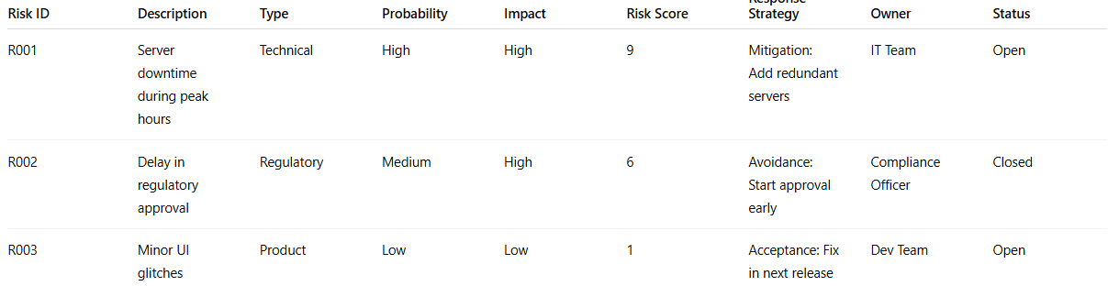
Risk ID | Description | Type | Probability | Impact | Risk Score | Response Strategy | Owner | Status
R001 | Server downtime during peak hours | Technical | High | High | 9 | Mitigation: Add redundant servers | IT Team | Open
R002 | Delay in regulatory approval | Regulatory | Medium | High | 6 | Avoidance: Start approval early | Compliance Officer | Closed
R003 | Minor UI glitches | Product | Low | Low | 1 | Acceptance: Fix in next release | Dev Team | Open
Risk Report Snapshot:
- Total risks: 15
- High priority risks: 3
- Mitigation actions completed: 5
- New risks identified this month: 2

🔹 Importance of Risk Documentation & Reporting
# Source: AI Source: Provided by: [Data Path: Persons Table -> ID Column: 1, Name_En Column: Motasem Essam] -> From: [Chatgpt (GPT‑5 Mini)] on [8/24/2025]
- Ensures transparency in risk management activities.
- Helps track progress and identify gaps in mitigation.
- Supports stakeholder communication and accountability.
- Provides evidence for audits and reviews.
- Facilitates continuous improvement in risk management practices.

✅ In short:
Risk Documentation & Reporting = Recording all risks, their analysis, responses, and status, and communicating this information to stakeholders to ensure transparency, control, and informed decision-making.

